**Project Report**

**Coal Lab**

**Name: Abrar Ul Abdin**

**Roll No: CS191007**

**Section: 3B**

**Instructor’s Name: Sir Zahid Hussain**

**Project Name:** **Multi Feature Calculator**

**Introduction:**

This project has been made on MIPS Assembly language MARS simulator. It contains all the basic features which a simple calculator needs to be. In this project we define separate function for every feature. Likewise function for addition, subtraction etc.

When the program started it gives a message to user for choice which feature user want to perform. Then OS take the user to that function or feature user needs to be perform.

**Description:**

I have divided the code into six (6) type of function. Which are define below.

**Functions**

1. **Function For Addition**

When user choose this function after pressing 1 its print the messages to enter the first and second number you want to add. When user enters the number we had stored these numbers into $f4 and $f6. Then used the built in function to add these two numbers then move the result to $f12. And then print the result using (li $v0, 4). Then The program ends.

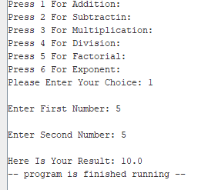

**2) Function For Subtraction**

When user choose this function after pressing 2 its print the messages to enter the first and second number you want to subtract. When user enters the number we had stored these numbers into $f4 and $f6. Then used the built in function to subtract these two numbers then move the result to $f12. And then print the result using (li $v0, 4). Then The program ends

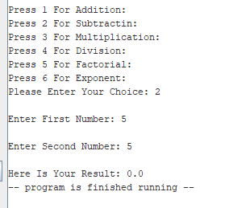

1. **Function For Multiplication**

When user choose this function after pressing 3 its print the messages to enter the first and second number you want to multiply. When user enters the number we had stored these numbers into $f4 and $f6. Then used the built in function to multiply these two numbers then move the result to $f12. And then print the result using (li $v0, 4). Then The program ends.

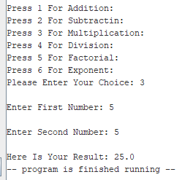

1. **Function For Division**

When user choose this function after pressing 4 its print the messages to enter the first and second number you want to add. When user enters the number we had stored these numbers into $f4 and $f6. Then used the built in function to divide these two numbers then move the result to $f12. And then print the result using (li $v0, 4). Then The program ends.

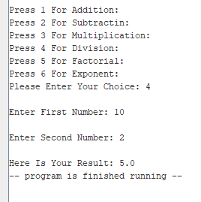

1. **Function For Factorial**

When user choose this function after pressing 5 its print the messages to enter the number to find factorial. Then we store this number into $v0. Then load the number into $a0 and sending like an argument and called the find Factorial function which we also define inside the function. Then we create a check whether the number is zero, one or negative number. If it is then it jumps to factorial done function. If it is not zero, one or negative it will go ahead and subtract 1 from users value and recall the function. Here is the Magic when it will call the function again its multiply the user number from the value which we find from subtracting -1 and stored the result in $v0. The process will be repeated until the users value become 1. Then when the function factorial done is called it will be back on the main function where we call the find Factorial function. Then simply print the value of $v0 after.

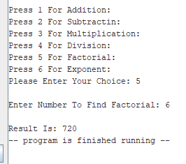

1. **Function Of Exponent**

When user choose this function after pressing 6 its print the messages to enter the number for variable X like base. Then print the message for Y like power.

when user gives the two values then we move these values to $a0 and $a1 from $s0 to $s1. Then we used jal to jump to the exponential function.

Then we used a check mark to check to see if $t0 is equal to $a1 if not it continues, if it is it jumps to end. Where the end function will restore the stack and back to main code. If it not then simply multiply these numbers then add 1 to power and the loop will again executed.

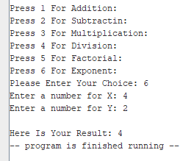

The End!

Thank You.